How to apply for an 18+ Oyster card

Step 1: Go to https://photocard.tfl.gov.uk/tfl/showLogon.do?selection=student
Step 2: Ensure that 18+ Student Oyster has been selected
Step 3: Click on “Create web account”

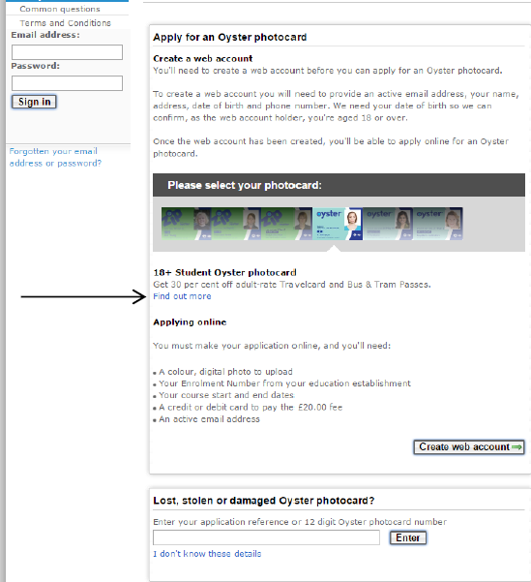

Step 4: Enter The University of Northampton or click “view list of all available establishments” and the click “Apply Now”

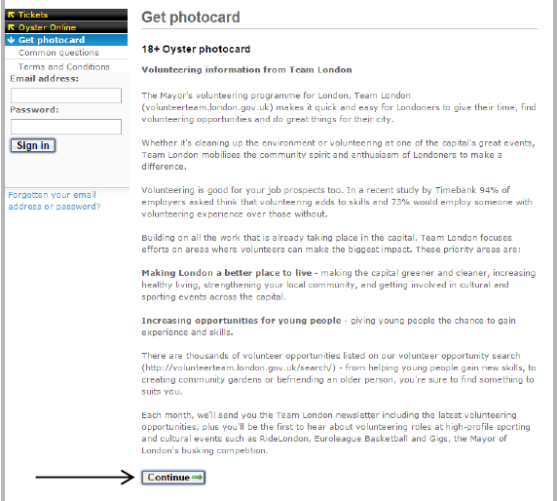
Step 5: Click “Continue” at the bottom of the page

Step 6: You will then have to create an account. Enter your email address and create a password, then click “Create account” at the bottom the page.
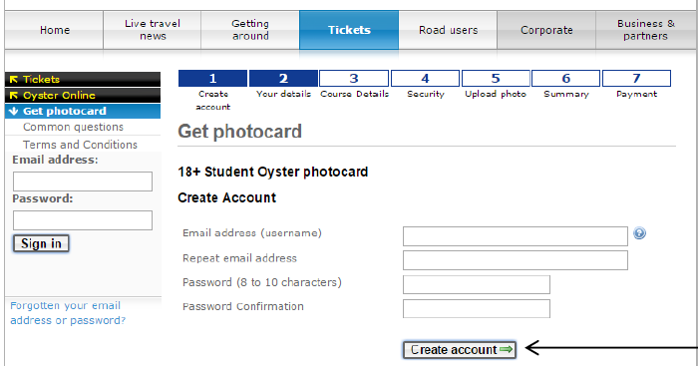

Step 7: Fill in your details on each section of the page:
- Course details
- Security
- Upload photo
- Summary and payment
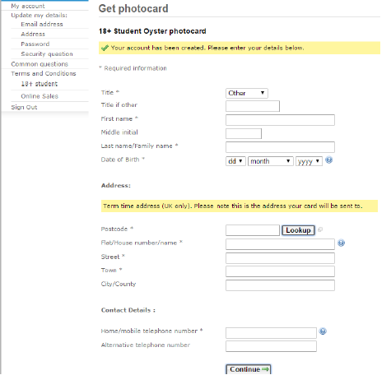

Once all the information has been entered, your application will be sent to us for approval. We aim to approve application within 3-5 working days. For any other oyster card queries please contact – contactus@tfl.gov.uk

